**Optional population ecology worksheet**

The Common Wall Lizard (Podarcis muralis) is native to Europe. This lizard was first brought to British Columbia in 1967 to be housed in a private zoo near Victoria, B.C. In 1970, 12 European Wall Lizards were intentionally released when the zoo closed. Since their initial release, the distribution and abundance of these lizards has increased. This lizard species can now be found throughout most of southern Vancouver Island and has also been spotted in Vancouver and the Okanagan.

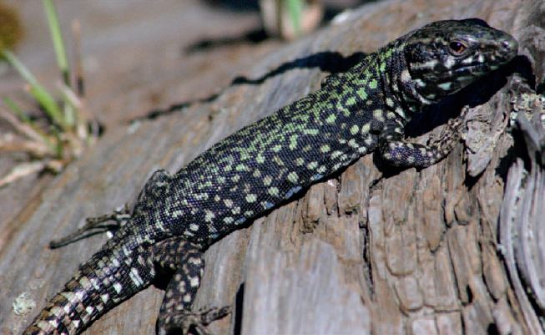

A) The figure below shows the estimated population size of the Common Wall Lizard at one location on Southern Vancouver Island from 1970-2010.

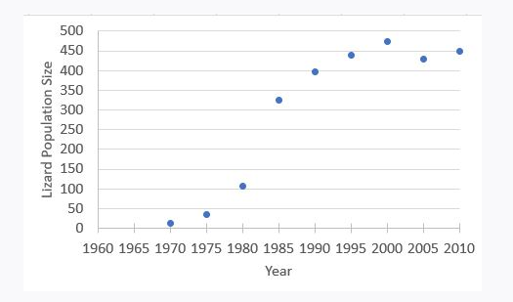

Based on the figure above, what is the environment’s carrying capacity for the Common Wall Lizard at this location?

B) Based on the figure in Question A above, during which years was the population growing near-exponentially? Circle the appropriate area on the graph.

C) Based on the figure in Question A above, in approximately what year did density-dependent factors start to strongly affect the per capital growth rate? Circle the appropriate area on the graph.

D) List one **density-dependent** factor that could affect the population growth rate of the Common Wall Lizard population on Vancouver Island and briefly explain how this factor could potentially affect the population per capita growth rate (*r*) of the lizards.

E) List one **density-independent** factor that could affect the population growth rate of the Common Wall Lizard population on Vancouver Island and briefly explain how this factor could potentially affect the population per capita growth rate (*r*) of the lizards.

F) Recently, a population of Common Wall Lizards has been found in the Vancouver area. You have been hired to conduct a mark-recapture study to estimate the population size of this lizard population.

In your initial visit, you capture 100 lizards and mark them by painting an individual number on the bottom of their body. You return one month later and capture 150 lizards. 60 of these lizards are marked. What is the population size of Common Wall Lizards at your study site? Use the Petersen-Lincoln Index for your calculations (N/M = n/m). You do not need to show your work.

G) What is one assumption that must be met for you to have confidence that your estimated population size is an accurate estimate of the true lizard population size? (1 mark)

H) Below is a survivorship curve for the Common Wall Lizard. Which type of survivorship curve best fits the data for the Wall Lizards? Explain your choice.

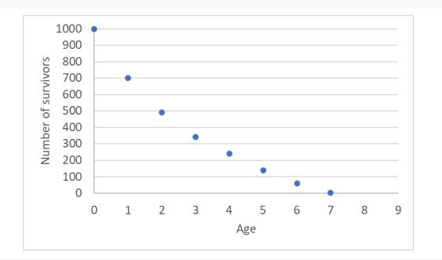

I) Biologists are concerned that as the abundance and distribution of the European Wall Lizard increases, the lizard will come into contact with a native lizard species, the Northern Alligator Lizard (*Elgaria coerulea*)

Based on the information in the table provided below (on the next page), why would biologists be concerned if these two lizard species interact? Explain your answer. In your answer refer to the interaction that would occur between these two species, **one** potential ecological outcome of this interaction and the potential fitness effects for the Northern Alligator Lizard.

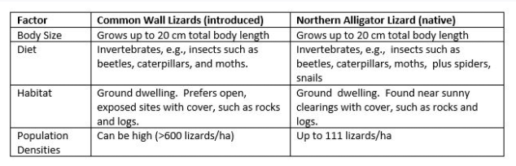

J) Below are some life history traits for the European Wall Lizard and the Northern Alligator Lizard.

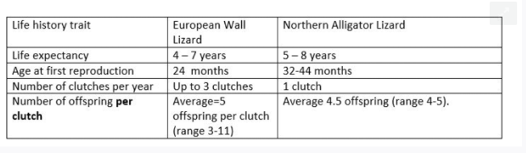

Which of these two species is more K-selected in its life history? Briefly justify your answer making use of the data in the table.